Smokey the CyberBear

# **Managing wildfires affecting remote communities**

Wildfires are hitting locations around the globe every year and with every large fire another chunk of the environment is burning. Wildlife is displaced from its natural habitat, human communities are affected both directly by the fire or indirectly the smoke that is produced as a result of the burnings. The damages to humans and environment are at the same time moral and economical and must be supported by all of us.

In remote areas or communities where information of this type that already exists does not find its way as easily due to lack of internet or GSM infrastructure this issue is even more dangerous for both humans, which might be alerted too late of the fire, and for the nature itself because a such a fire in a remote area can be hard to report, and the delay could represent the difference between a controlled fire and a catastrophe.

# **About Us**

We are a team of engineers, engineering students, and software developers who are passionate about finding innovative solutions to the issues that affect us all. We believe that protecting nature and human life falls within the responsibility of all of us. We chose this issue because we believe that of the challenges presented this allowed us to use our expertise to propose a viable solution that would do the most good to the most people.

# **Smokey the CyberBear**

We are proposing a solution in which publicly available NASA data is used in conjunction with community engagement and measurements from sensors placed in the forest in order to alert the communities and local authorities as fast as possible about possible to be able to contain the fire in the shortest possible timeframe. This solution should be able to connect to the internet in at least one point to be able to communicate with a computer that does the data processing but at the same time it has to be able to expand in areas where there is no internet connection. The system should be aware of its coordinates and be able to reproduce them if needed. Also the system should be able to function a long time without regular maintenance. Our solution is called “Smokey the CyberBear”, Smokey is a system based on a LoRaWAN mesh network which, once deployed, would allow the sending of emergency messages and highly important information to and from remote areas and communities that don’t have access to GSM or internet infrastructure. The system consists of two main types of devices, namely, a gateway device which may connected to internet and is more powerful and a repeater device which is part of the mesh networks that connects multiple gateways together. The repeater device also has CO2 sensor and flame detecting infrared sensor. The sensors on the repeaters allow it to have a better chance to early detect fires in remote areas where people rarely pass.

At least one gateway of a network must be connected to internet to allow communication with the satellite and weather APIs while the rest of the gateways can be outside internet coverage and used by remote communities to send emergency messages.

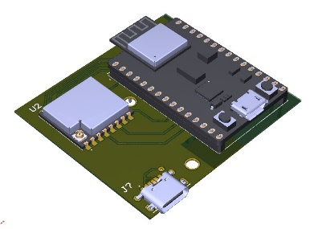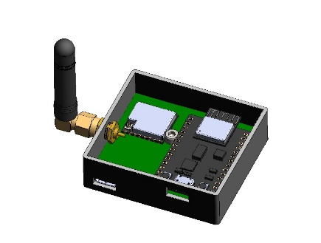The gateway devices will be plugged into the wall while the repeater devices will run of off 50W/h power banks that in our computation and with our suggested way of power management should run for about 10 months.

Gateway

Repeater

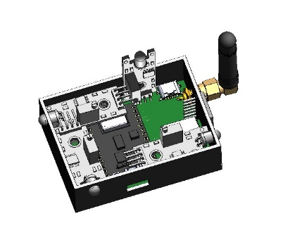

# **Issues**

Due to the small timeframe allocated for solving this issue the project is in a prototype state, meaning the code is functional and the hardware implementation works but it’s price can be lowered significantly, and the software has no user interface the exchange of data is done either trough console or trough code.

Other issues are regarding battery life, with our computations the battery should last about 10 months until it needs to be replaced. Self-charging solutions would need to be adapted by location and it was not within our grasp as it would induce unforeseen issues and challenges.

# **Future improvements**

The system is extremely modular and new devices can be added to the network as needed, most future improvements are related to user experience and user interface. This project is an early prototype, and the message transmission is only bidirectional not full-mesh, this can be extended in the future. Moreover, the API call is made only for the latest fire data and it does not take into consideration the location of the device. This can be changed to read all the latest satellite data and only send forward the information if the coordinates fall within the governance of the gateway.

We have initially intended to create an AI powered installation guide which would allow the for the distance and spread of the devices to be dynamically adjusted and perfectly positioned taking into consideration the risk factor of an area..